Chapter 1- The lakehouse paradigm
Discover lakehouse reliability features
You've just joined Metro Transit Analytics as a junior data engineer. The company manages city-wide transportation data and recently migrated from a data lake to a Databricks Lakehouse.
You've been logged into a Databricks workspace. On your first day, your manager asks you to explore the workspace and find concrete evidence of the reliability features that set the lakehouse apart from the plain data lake the company used to run.

- Navigate to the Catalog and open the silver_taxi_trips table. Examine the columns and their enforced data types on the Overview tab - notice types like timestamp, double, and int. This is schema enforcement, something a plain data lake doesn't provide.
- Open the SQL Editor and run the following query: DESCRIBE HISTORY bronze_taxi_trips; Note: You may be prompted to attach to a compute resource. Select the Serverless Starter Warehouse and click Start, attach and run. This shows the table's transaction log - every change is tracked with a version number and timestamp.
- Return to the Catalog and check the table's Details tab. Confirm the Delta format - this is the technology that enables ACID transactions and the transaction log you just saw.
- Based on what you discovered in the workspace, what does the Databricks Lakehouse add on top of a standalone data lake?
R: Schema enforcement, a transaction log that tracks every change, and ACID transactions - all powered by the Delta format.

Lakehouse vs. warehouse trade-offs
Before the lakehouse migration, Metro Transit Analytics ran a data warehouse for BI dashboards and a separate data lake for data science. Maintaining both was expensive and led to constant data duplication.
Your manager asks you to explore the workspace and see for yourself how the lakehouse handles both workloads - structured analytics and flexible raw data storage - on a single platform.
- Navigate to the Catalog and open the bronze_taxi_trips table. Click the Sample Data tab to preview the raw data. Notice the loosely-typed structure - mixed formats, string-typed numbers, and nulls. This is the kind of data a traditional warehouse would reject.
- Open the SQL Editor and run the following query on the clean silver layer, The lakehouse handles warehouse-style analytics just as well as a traditional warehouse:
SELECT pickup_zone,
COUNT(*) AS trip_count
FROM silver_taxi_trips
GROUP BY pickup_zone
ORDER BY trip_count DESC LIMIT 5;

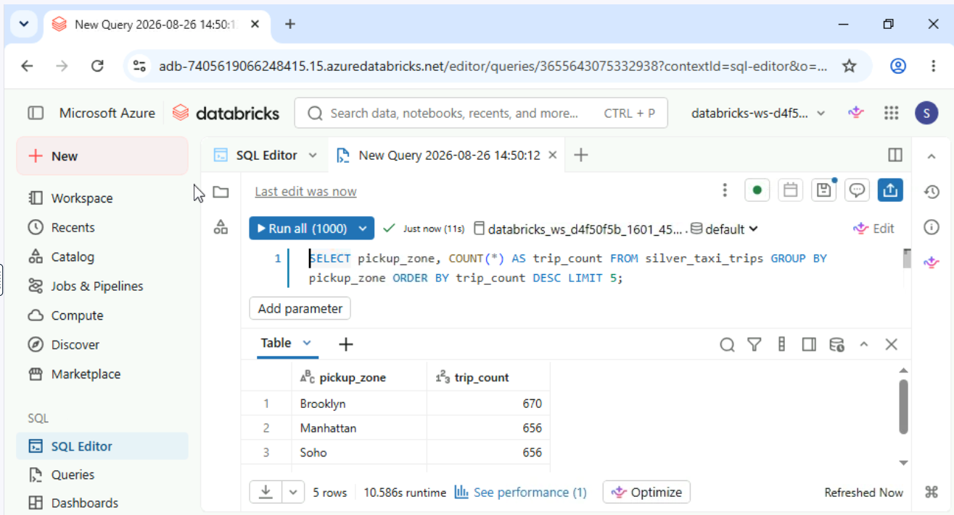

- Return to the Catalog and compare the Overview tabs of bronze_taxi_trips and silver_taxi_trips. Bronze has every column as string; silver has proper types like timestamp and double - the same platform stores both.
- A colleague asks: "Why didn't we just move everything to the data warehouse instead of building a lakehouse?" Based on your exploration, what's the best response?
R: The warehouse can't efficiently store raw, semi- structured data, and scaling it for all workloads would be costly. The lakehouse handles both raw ingestion and structured analytics on one platform.
Explore the medallion layers
Now that you're familiar with the workspace, your manager at Metro Transit Analytics wants you to understand how the team's taxi trip data is organized. The pipeline uses the medallion architecture - bronze, silver, and gold layers.
Three tables are already loaded: bronze_taxi_trips, silver_taxi_trips, and gold_taxi_daily_summary. Explore each layer to see how data quality improves as it moves through the pipeline.
- Navigate to the Catalog and open each of the three tables - bronze_taxi_trips, silver_taxi_trips, and gold_taxi_daily_summary. Compare their Overview tabs. Notice how bronze columns are all string, silver has proper types like timestamp and double, and gold has aggregated columns like avg_fare and trip_count.
- Open the SQL Editor and run the following query to compare data quality between bronze and silver, Notice how the silver layer has cleaned out the nulls.
SELECT 'bronze' AS layer,
COUNT(*) AS null_count
FROM bronze_taxi_trips
WHERE passenger_count IS NULL
UNION ALL
SELECT 'silver',
COUNT(*)
FROM silver_taxi_trips
WHERE passenger_count IS NULL;

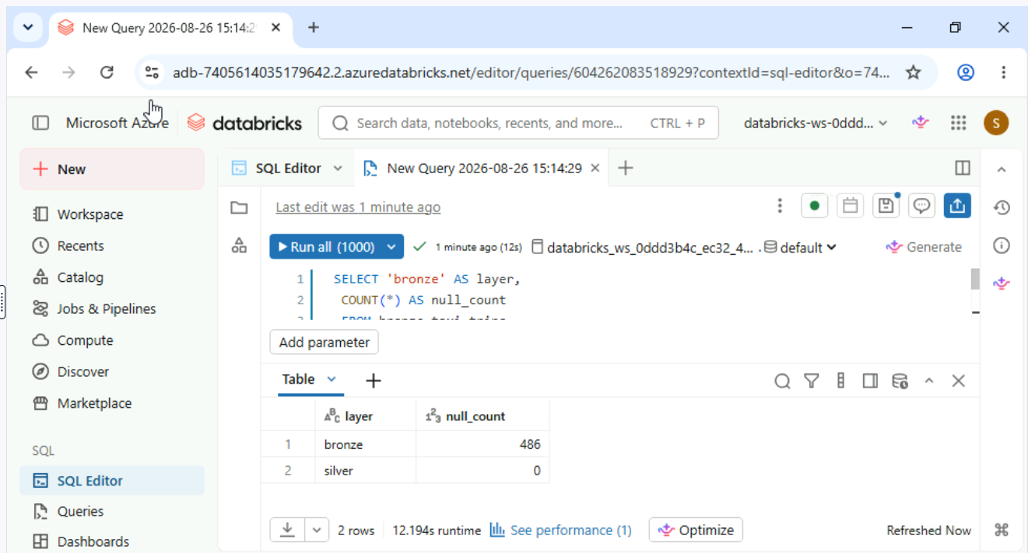
- Run this query to see the business-ready gold layer in action. These daily summaries are pre-computed - ready for dashboards without any additional transformation.
SELECT * FROM gold_taxi_daily_summary
ORDER BY trip_count
DESC LIMIT 5;
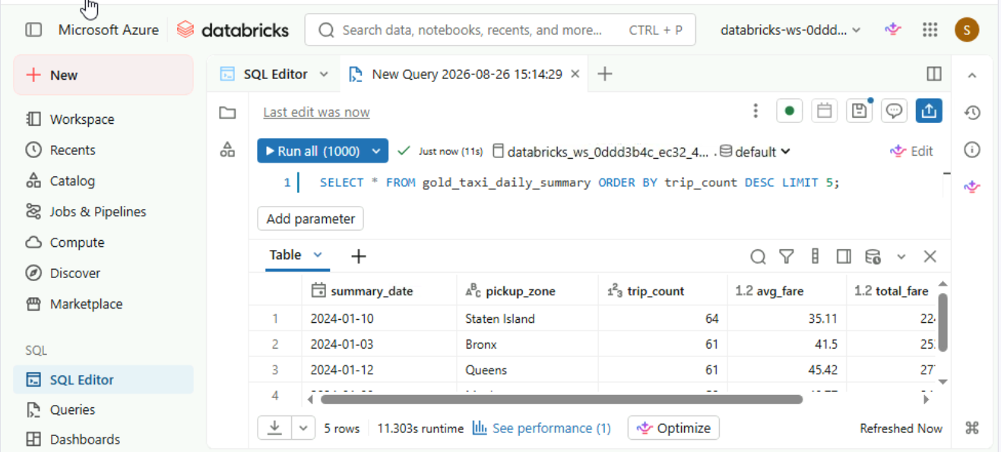

- Based on your exploration, which statement best describes the relationship between the three medallion layers?
R: Bronze stores raw data as-is with quality issues, silver cleans and validates it, and gold aggregates into business-ready summaries.

Where are audit logs stored?
The compliance officer at Metro Transit Analytics has a follow-up question after the security review. The company's data residency policy requires all logs to remain within your own cloud infrastructure.
Explore the workspace to find where Databricks stores audit logs and how to access them.
- Navigate to the Catalog and look for system tables that might contain audit or activity log data.
- Browse the system catalog hierarchy to locate audit-related tables. Note which schema they belong to.
- Open the SQL Editor and run the following query, examine the types of events captured - timestamps, user IDs, and action types.
SELECT *
FROM system.access.audit
LIMIT 10;

- Where does Databricks store audit logs, and how can your team access them?
R: Audit logs are stored as system tables in your own cloud account and can be queried with standard SQL.

Chapter 2 – Compute and Notebooks
Create and configure a cluster
You're a data engineer at Meridian Analytics, a healthcare data company. Your team lead has asked you to configure a new interactive compute environment for exploratory data analysis on patient engagement data.
Walk through the cluster creation form to understand the options - do not click Create, just review the configuration.

- Navigate to Compute and confirm you are on the All-purpose compute tab. Click Create with Personal Compute to open the creation form. Name the cluster patient_analysis and select the latest LTS runtime from the Databricks Runtime dropdown. Do not click Create yet - review the settings first.
- Review the Preferred node type (VM size and memory) and the Terminate after timeout (auto-shutdown for cost control). Click Cancel when you're done reviewing - do not create the cluster.
- What does the Databricks Runtime version determine for your cluster? R: The pre-installed versions of Spark, Delta lake, and included libraries.

Manage and configure a cluster
You're a data engineer at Meridian Analytics. Your team has a shared cluster called meridian_shared_etl that runs daily ETL jobs.
Your manager wants you to review its configuration to understand the cost controls - auto-termination and node type - before the team wraps up for the evening.
- Navigate to the Compute section. Find the meridian_shared_etl cluster and click on it to open its configuration page.
- Review the cluster's configuration: the Terminate after setting, the Preferred node type, and the Databricks Runtime version. Note how auto-termination helps control costs by shutting down idle clusters automatically.
- After terminating the cluster, what happens to its configuration and in-memory data? R: Configuration is preserved, but in-memory data is lost

Build a multi-language notebook
You're a data engineer at Meridian Analytics. Your team maintains a data quality pipeline that combines Python transformations with SQL validation queries.
Create a new notebook that loads the silver_taxi_trips table using Python, queries it with SQL, and documents your work with Markdown.
- Create a new Python notebook in the Workspace. Attach it to the available compute resource.
- In the first cell, load the silver_taxi_trips table into a DataFrame using: df = spark.table("silver_taxi_trips"). Display the results with: display(df)
- In a new cell, use the %sql magic command to run, This runs SQL in a Python notebook without changing the default language.
SELECT COUNT(*) AS total_trips FROM silver_taxi_trips
- In another new cell, use the %md magic command to write a Markdown heading: ## Trip Data Summary Run the cell to verify it renders as formatted text.
- You used `%sql` in a Python notebook to run a SQL query. What happens to the next cell you create? R: The next cell uses the notebook’s default language (Python)
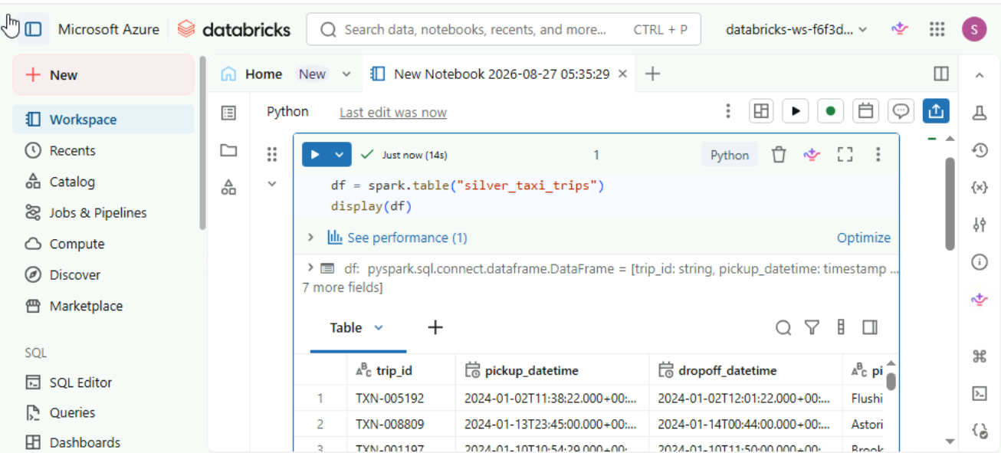
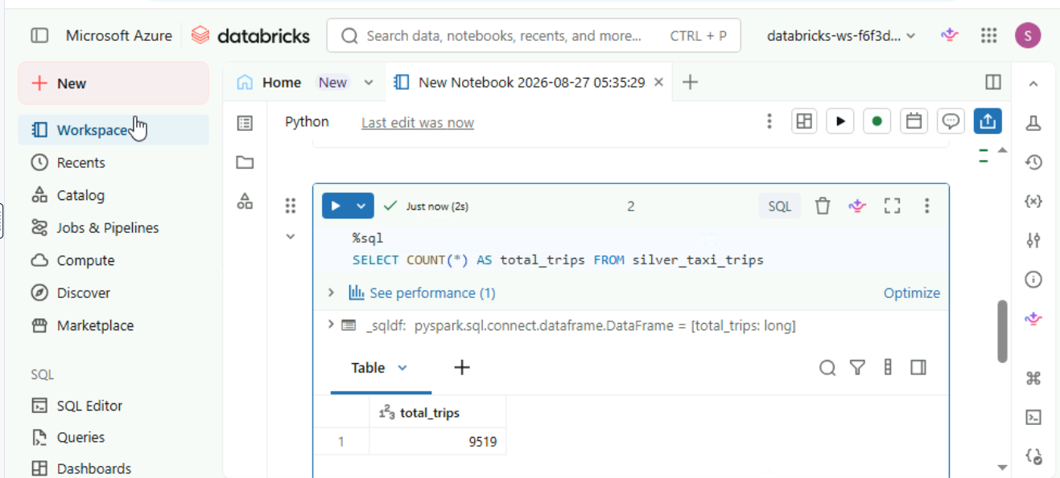
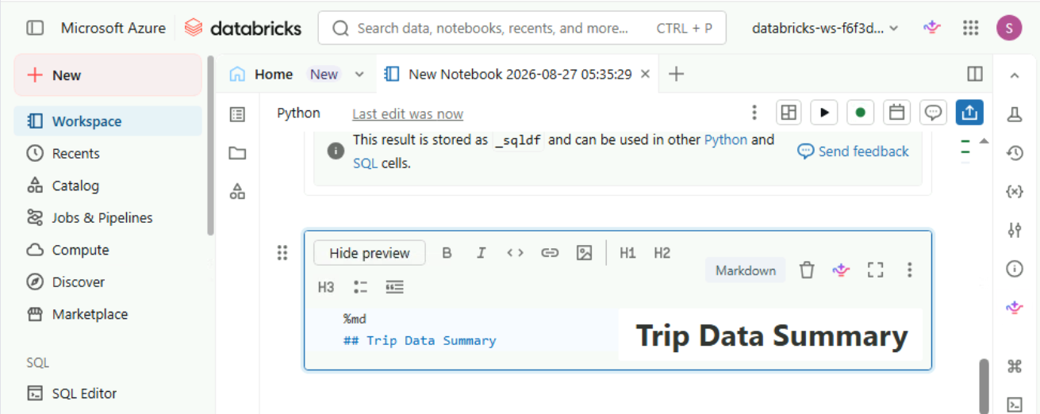

Explore notebook version history
At Meridian Analytics, your team is discussing how to track changes to notebooks. Before adopting Git integration, your manager wants everyone to understand the built-in versioning that's already available.
Open the notebook you created earlier and explore its version history.

- Navigate to the Workspace and open the Python notebook you created earlier (the one with %sql and %md cells).
- Add a new cell with a comment: # TODO: add data quality checks. Save the notebook to create a new version.
- Open the notebook's version history (look for a clock icon or link in the right toolbar). Observe the list of saved versions - each has a timestamp showing when the notebook was saved.
- What is a limitation of built-in notebook version history compared to Databricks Repos? R: It only provides a linear history with no branching support

Chapter 3- Governance and sharing
Unity Catalog hierarchy
You're a data platform engineer at NovaTech Solutions. A new team member asks where all the tables live and how they're organized.
Explore the Unity Catalog hierarchy to see how data is structured into catalogs, schemas, and tables - the three-level namespace that governs everything in Databricks.

- Navigate to the Catalog and identify the top-level catalogs. Expand one to see the schemas nested within it.
- Expand a schema and browse the tables, views, and functions it contains. Note the full three-level path (catalog.schema.table) shown for each object.
- Open the SQL Editor and run the following query to verify the three-level naming convention: SELECT * FROM default.client_engagement_gold LIMIT 5;
- In Unity Catalog's three-level namespace, which level directly contains tables, views, and functions? R: Schema
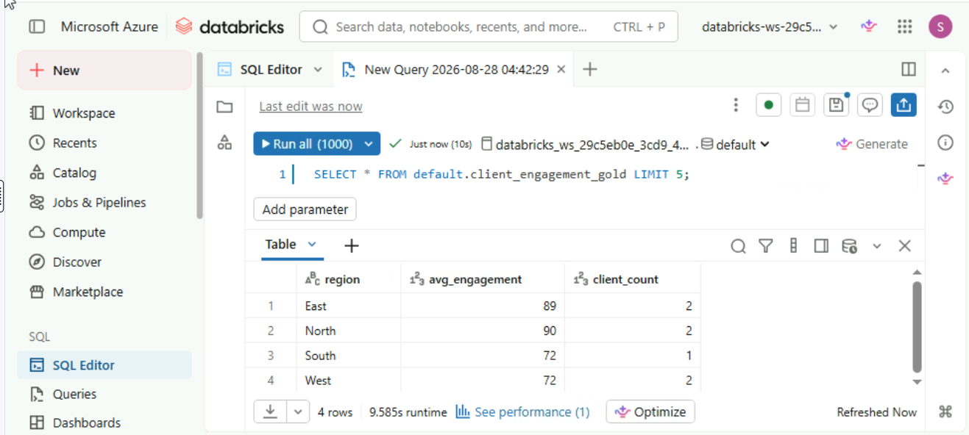
Explore table metadata in Unity Catalog
Now that you understand the catalog hierarchy, a new analyst at NovaTech Solutions needs to understand the client_engagement_silver table before using it in a report.
Use Unity Catalog to explore the table's metadata - its columns, data types, and properties - so you can confirm it has the right data.

Navigate to the Catalog and locate the client_engagement_silver table in the default schema.
Review the Overview tab to identify the table's columns and their data types.
Open the Details tab and find the table's storage format and location.
What does Unity Catalog track beyond just table schemas and column definitions? R: Lineage, access permissions, and table properties like storage format and location
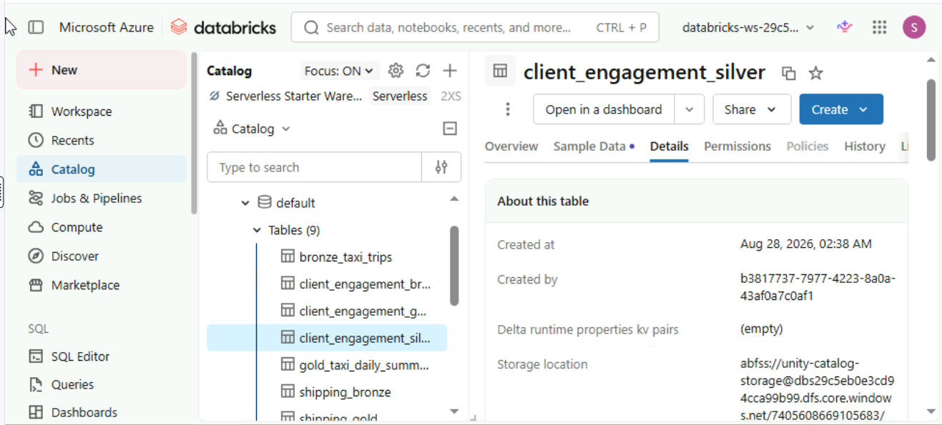

Create a Delta Share
You're a data platform engineer at NovaTech Solutions. An external partner, Apex Consulting, needs access to your gold-layer engagement metrics for a joint analysis.
Create a Delta Share from the client_engagement_gold table and register the partner as a recipient - all without making copies of the data.
- Navigate to the Catalog and locate the client_engagement_gold table in the default schema.
- Share the table via Delta Sharing. Create a new share called partner_engagement_share and add a recipient called apex_consulting.
- Verify the share was created by clicking Share on the table detail page and selecting View all shares. Open partner_engagement_share and confirm the correct table is listed.
- When the partner queries the shared table, where does the data physically reside? R: The data remains in your cloud storage – the partner reads it live

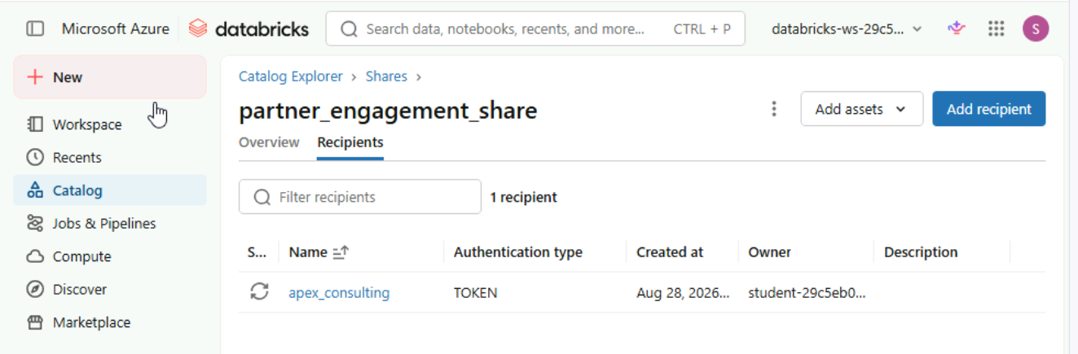

Add a table to a Delta Share
Apex Consulting now also needs the silver-layer engagement data for deeper analysis. Rather than creating a separate share, add the client_engagement_silver table to the existing partner_engagement_share - keeping all shared data organized in one place.
This is how real teams manage shares: one share per partner, with multiple tables added over time as needs evolve.

- Navigate to the Catalog and open the client_engagement_silver table. If your session restarted, first recreate partner_engagement_share from client_engagement_gold before continuing.
- Click Share > Share via Delta Sharing on the client_engagement_silver table. Select Add to an existing share and choose partner_engagement_share.

- Open partner_engagement_share via Share > View all shares. Verify that both client_engagement_gold and client_engagement_silver are now listed in the share.
- When you add a new table to an existing share, what happens for the recipient? R: The recipient automatically gets access to the new table - no action needed on their side
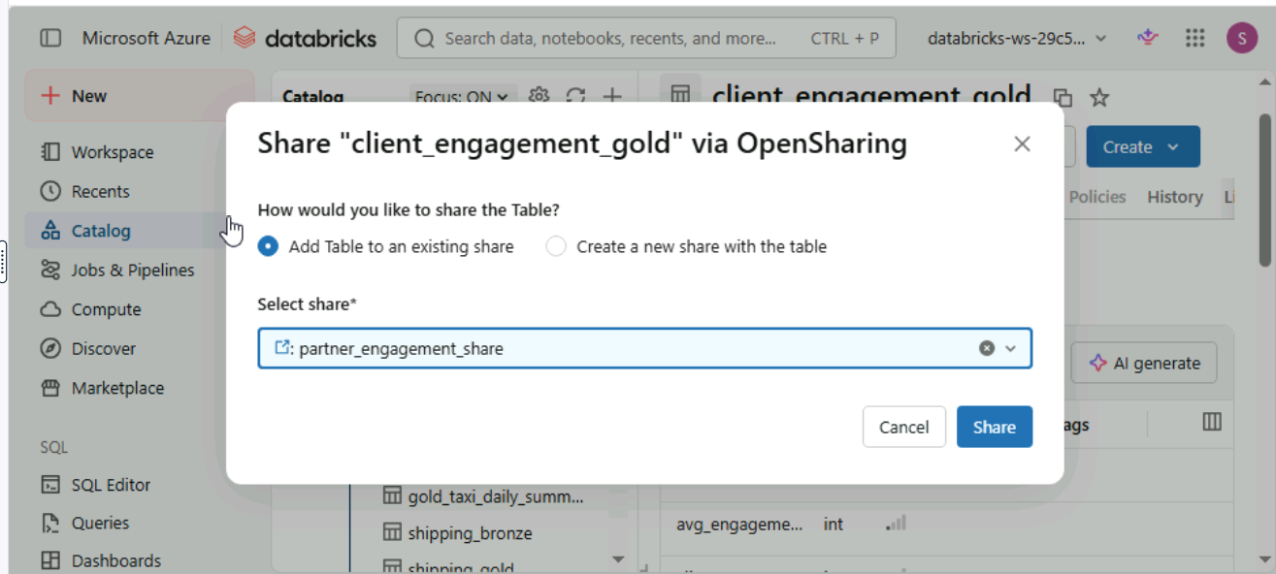
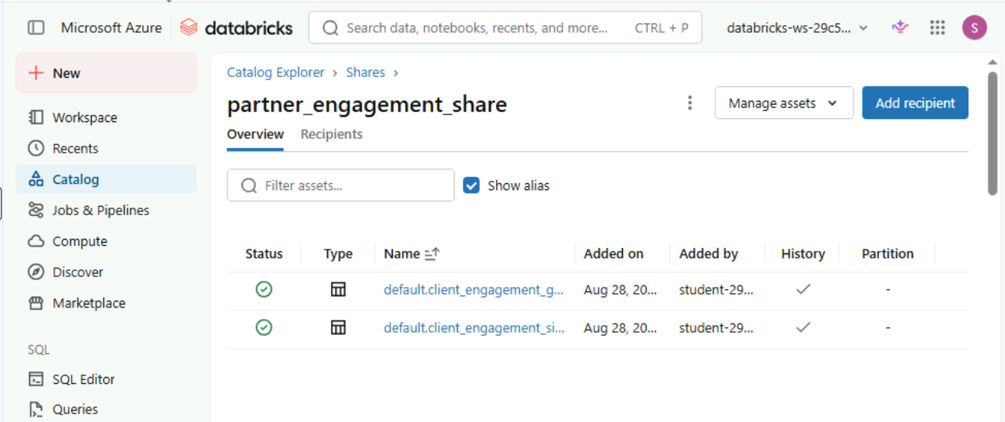

Native vs. open protocol sharing
At NovaTech Solutions, a new external partner - AnalyticaBI - uses Snowflake and needs access to your shared engagement data. Since they are not on Databricks, you'll need to use open protocol sharing.
Navigate to the existing share, create an open protocol recipient, configure a token, and locate the activation link.
- Navigate to client_engagement_gold in the Catalog and open partner_engagement_share via Share > View all shares. If your session restarted, recreate the share with client_engagement_gold first.
- Go to the Recipients tab inside the share and click Add recipient. Open the dropdown and select Create new recipient. Observe the two authentication types - Databricks (native) vs. Open (open protocol).
- Create an Open recipient called analytica_bi with a token expiry of one day. After creation, locate the activation link - this is what the partner uses to connect from Snowflake.
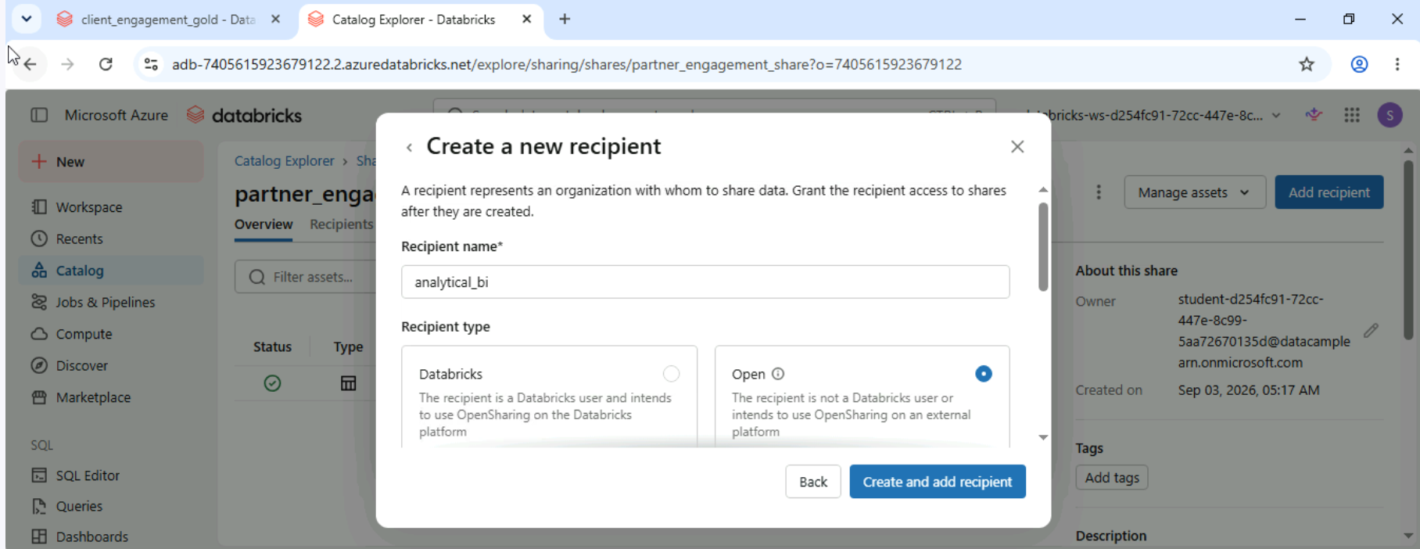
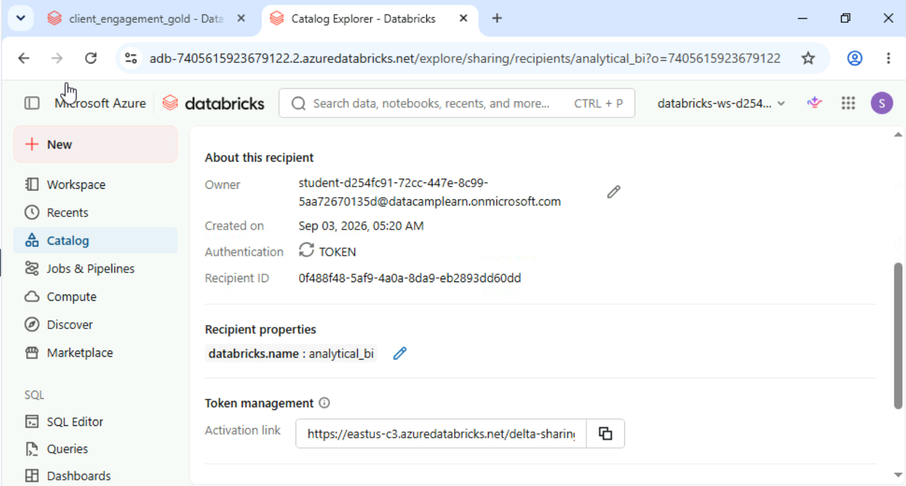

- You just generated an activation link for the Snowflake partner. What does the partner use this link for? R: To download a credentials file that configures their Delta Sharing client to read data from your storage
Cross-cloud sharing costs
NovaTech Solutions hosts its workspace on Azure in the US East region. A new partner, GlobalTech, runs analytics on AWS in EU West. They want live access to your client_engagement_gold table via Delta Sharing. Your finance team has flagged a cost concern.
Explore the sharing setup to understand the cost implications of cross-cloud data access.
- Navigate to client_engagement_gold in the Catalog and open a share via Share > View all shares. Confirm the data remains in your cloud region. If your session restarted, recreate the share with client_engagement_gold first.
- Review the recipient's cloud and region. Consider what happens when they query data stored in a different cloud provider and region.
- Query the shared table's row count. Consider how the data volume affects costs when the recipient reads this data across cloud providers.
- Which cost consideration is most important when sharing data across cloud providers and regions? R: Cloud egress charges for data read across providers and regions

Setting up a federated connection
At NovaTech Solutions, a new team member needs to set up Lakehouse Federation to query an external MySQL database from Databricks. They know the individual steps but aren't sure of the correct order. Help them arrange the steps in the right sequence.
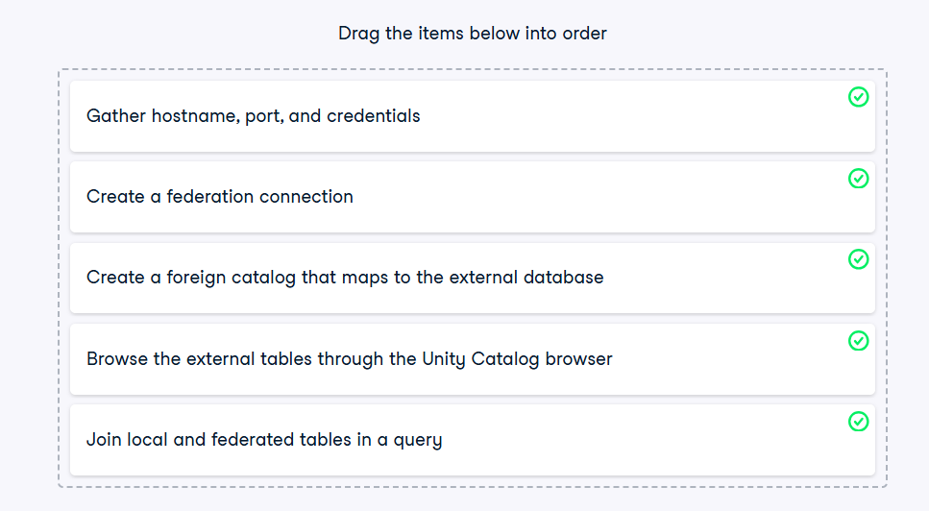
Chapter 4 – Deployment and next steps
Examine a DAB project structure
You're a data engineer at Summit Retail Corp. Your team recently migrated from manual UI-based deployment to Databricks Asset Bundles. A pre-built bundle project has been cloned into your workspace.
Explore its structure and identify the key components that make up an Asset Bundle.
- Navigate to Workspace > Users > your user folder > repos and open the retail-etl-bundle project folder.
- Locate the databricks.yml file and review its contents. Identify the configured deployment targets.
- Find the resources folder and identify what types of resources (jobs, pipelines) are defined in the bundle.
- Locate the source notebooks that the bundle deploys and note how they are referenced in the job definitions.
- Based on the `databricks.yml` you just reviewed, which deployment target is set as the default? R: dev
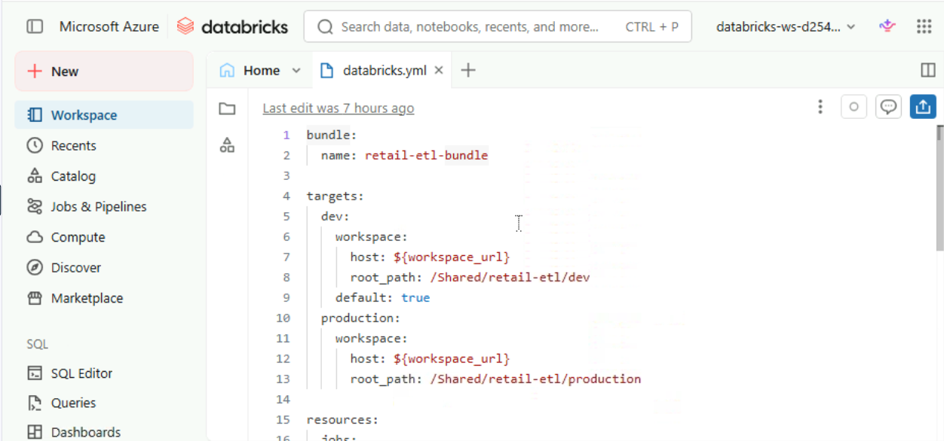

DAB vs. traditional deployment
Your team at Summit Retail Corp is evaluating Databricks Asset Bundles vs. their current manual deployment process.
Explore the DAB project in the workspace to see how infrastructure-as-code compares to traditional UI-based deployment.
- Open the databricks.yml file in the bundle project. Review how deployment targets are defined in code - identical configuration can be deployed to any environment.
- Open the src folder and review the pipeline notebooks inside. Notice how code and configuration live together in one project - unlike the UI approach where notebooks and job settings are managed separately.
- Navigate to the Jobs section from the left sidebar. Notice the page is empty - now compare that to databricks.yml, which already defines a complete job ready to deploy with a single command.
- What is the key advantage of using Databricks Asset Bundles over traditional UI-based deployment? R: DAB configuration is version-controlled, reproducible, and provides a full audit trail

Correct! DAB brings infrastructure-as-code practices: every change is tracked in Git, deployments are reproducible across environments, and the full history provides an audit trail. Manual Ul deployment lacks all of Compute these.
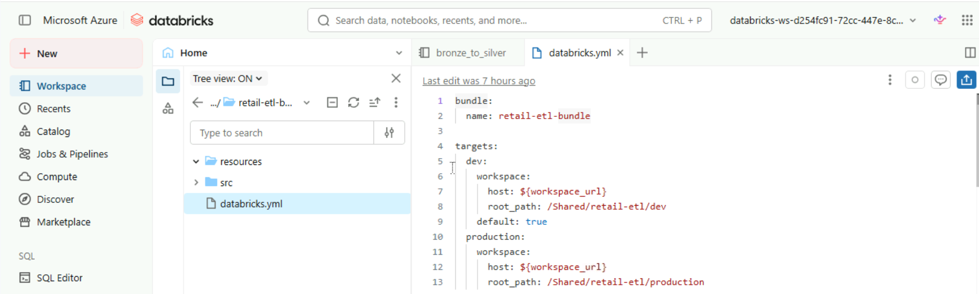
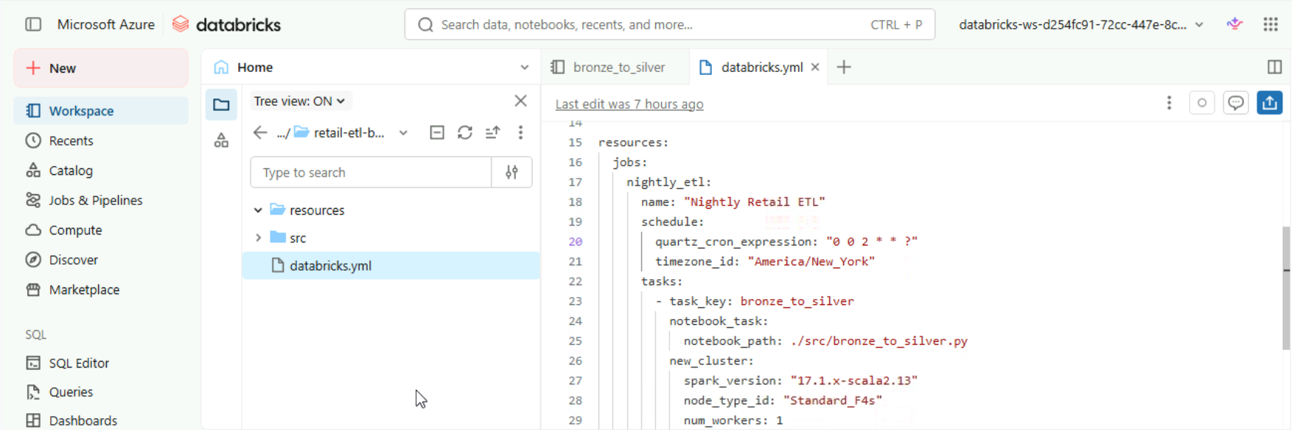
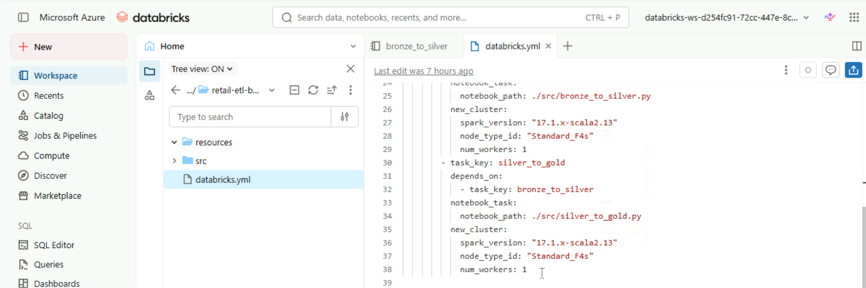

Inspect and modify an Asset Bundle
You're a data engineer at Summit Retail Corp. The team's Asset Bundle needs a configuration update before the next release.
- Open the databricks.yml file, inspect the current job and target definitions, and add a new staging target so the team can test deployments before promoting to production.
- Open the databricks.yml file in the retail-etl-bundle project (under Workspace > Users > your user > repos) and review the existing targets section.
- Identify the resources defined in the bundle - note the job name, its tasks, and the cluster configuration.
- Add a new target called "staging" with the workspace URL https://adb-staging.azuredatabricks.net and root path /Shared/retail-etl/staging.
Verify the bundle configuration is valid by reviewing the YAML structure for any syntax issues.
- Before deploying the updated bundle, which CLI command should you run first to check for configuration errors? R: bundle validate
Correct! `bundle validate` checks your `databricks.yml` for syntax errors, missing fields, and configuration issues before you deploy – catching Compute problems early.
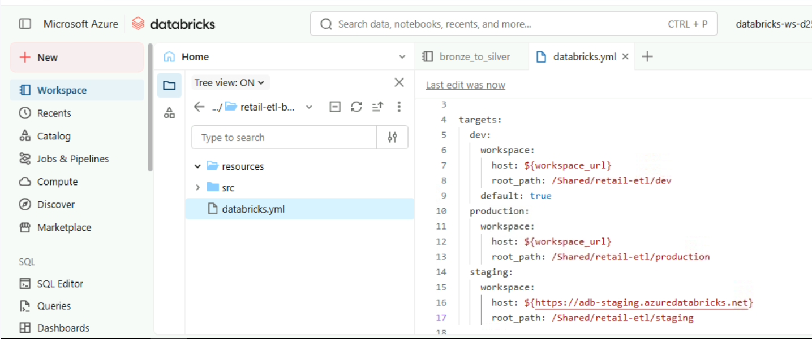

Trace a job from config to code
A junior engineer at Summit Retail Corp is reviewing the team's Databricks Asset Bundle for the first time. They need to find where job task definitions live - including which notebooks the nightly ETL job should run.
Help them navigate the bundle structure.
Open the databricks.yml file in the bundle project (under Workspace > Users > your user > repos) and locate the resources section.
Find the jobs subsection within resources. Identify the job names and their task definitions, including which notebooks they reference.
Examine a job task definition and find the notebook path it references. Verify the notebook exists in the project.
Where are job task definitions - including which notebooks to execute - specified in a Databricks Asset Bundle? R: In the `resources.jobs' section of `databricks.yml

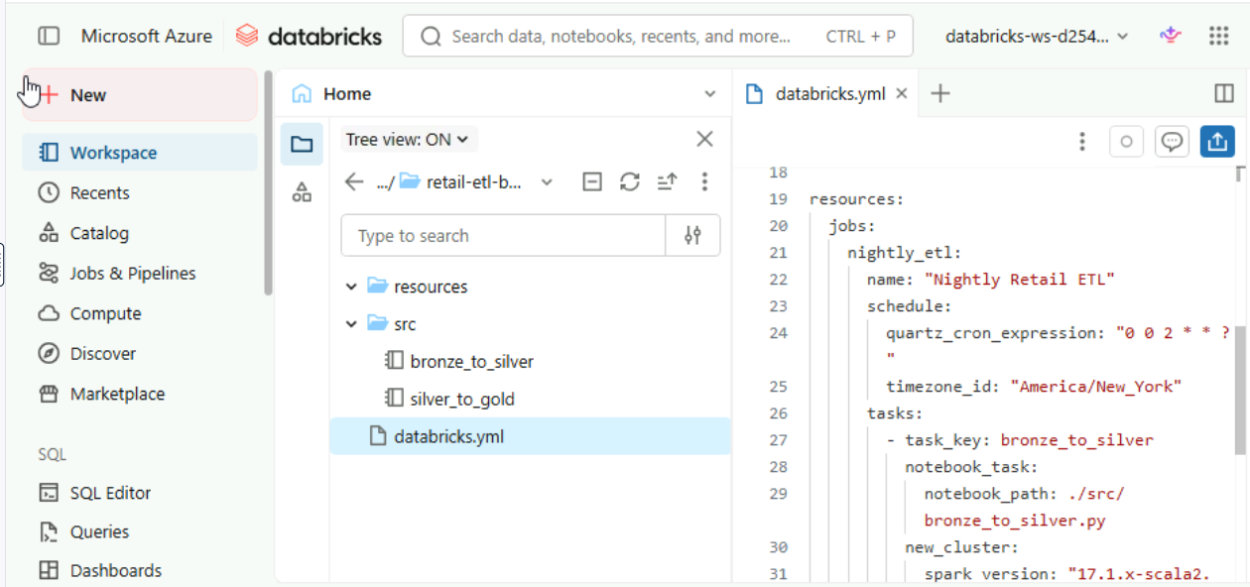

End-to-end lakehouse workflow
You're a data engineer onboarding a new data pipeline at Velocity Logistics, a shipping and logistics company. Your manager wants you to demonstrate end-to-end proficiency.
Configure the right compute, verify data quality across medallion layers, inspect governance lineage, and review the deployment bundle. This capstone exercise brings together everything you've learned in the course.
- Navigate to the Compute section and identify which cluster type and runtime would be appropriate for a scheduled nightly ETL job that processes shipping data.
- Open the SQL Editor and query the default.shipping_bronze table to see the raw data. Then query default.shipping_gold to compare the cleansed, aggregated output.
- Navigate to the Catalog, expand the default schema, and open the shipping_gold table. Review its columns and data types on the Overview tab, then check the storage format and location on the Details tab.
- Open the logistics-pipeline-bundle project (under Workspace > Users > your user > repos) and review the databricks.yml file. Identify the deployment targets and the job that runs the nightly ETL.
- A teammate wants to run this ETL pipeline as a scheduled nightly job and deploy it to production. Which combination of choices is correct? R: Use a jobs cluster and deploy with `bundle deploy --target production`
Correct! A jobs cluster is cost-optimized for scheduled workloads (it terminates after the job finishes), and deploying via Asset Bundles ensures the configuration is reproducible, versioned, and auditable.

Balancing security, cost, and governance
Velocity Logistics needs to share a gold-layer shipping dataset with an external partner on a different cloud provider. Security requires data stays in your account, finance wants minimal costs, and governance needs full audit visibility.
Review the sharing options in the workspace to find the best approach.
Locate the shipping_gold table in the default schema and verify its storage location. Confirm the data resides in your own cloud account.
Explore the Delta Sharing options. Consider whether native or open protocol sharing fits a partner who uses a different cloud provider.
Open the Details tab for the shipping_gold table in the Catalog. Verify the table owner and storage location to confirm governance visibility over the data you plan to share.
Which approach best balances security, cost, and governance for this cross-cloud sharing scenario? R: Use open-protocol Delta Sharing so the partner reads data live from your storage, with Unity Catalog governance

